Appendix A

Okanogan Overview Maps for

Fish Distribution within the Entire Basin
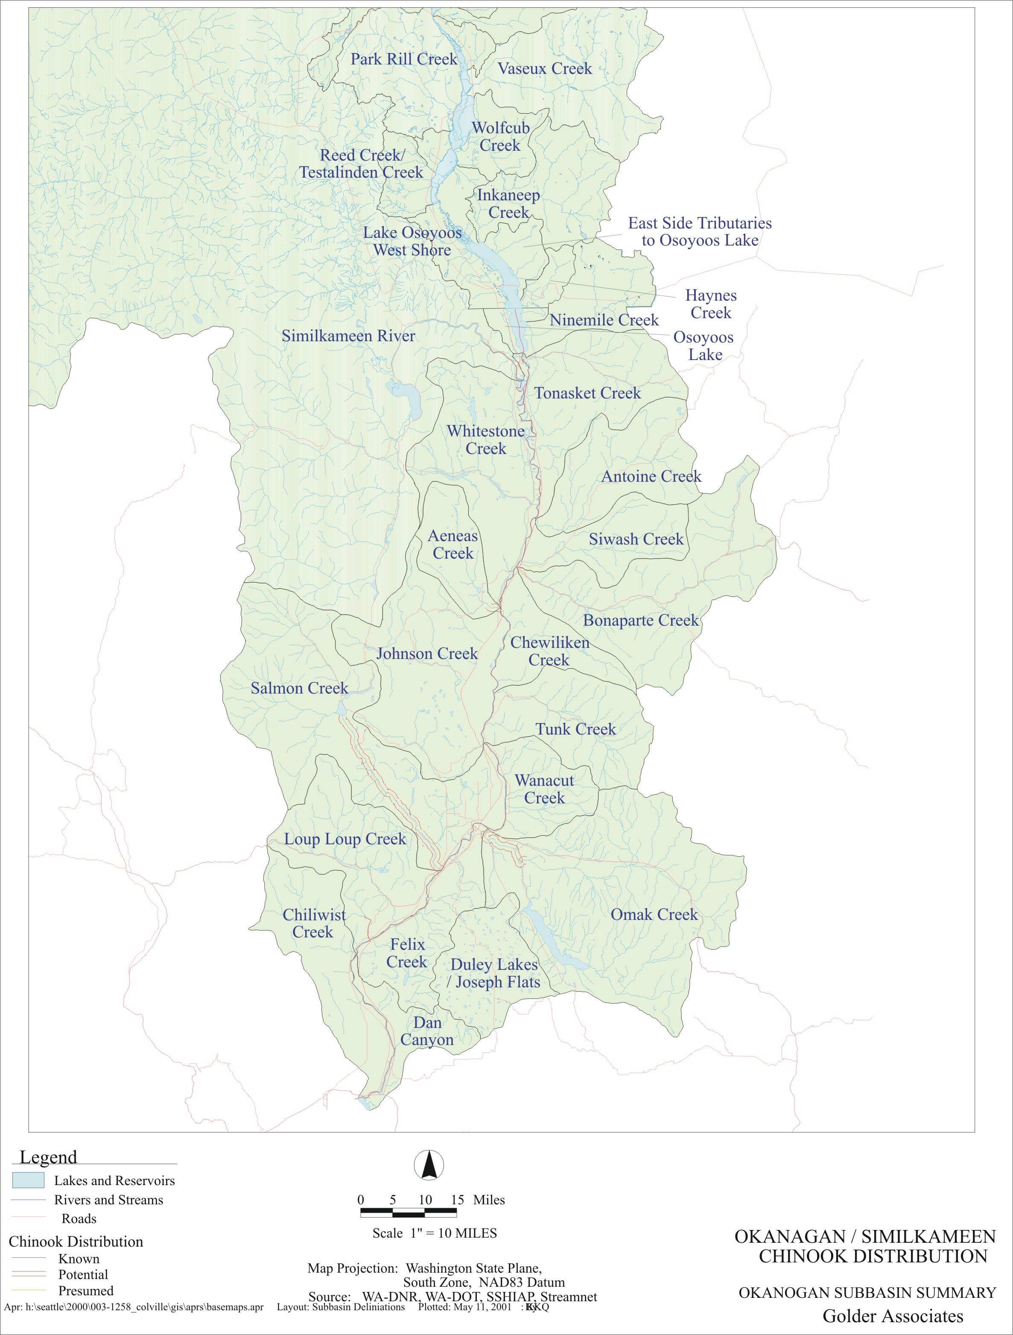
E-1. Chinook Salmon Distribution in the Okanogan/Similkameen River Basins.
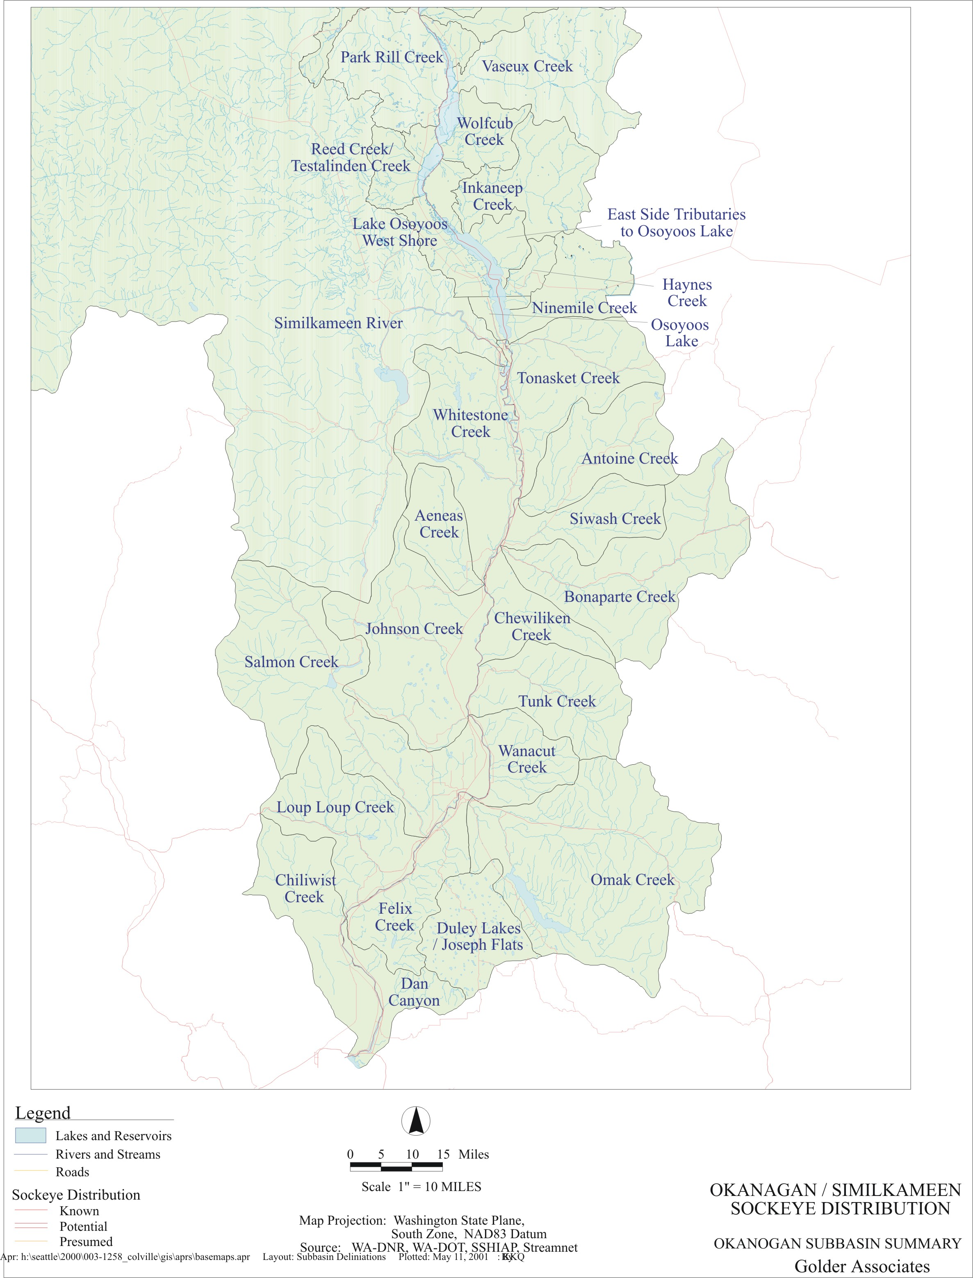
E-2. Sockeye Salmon Distribution in the Okanogan/Similkameen River Basins.
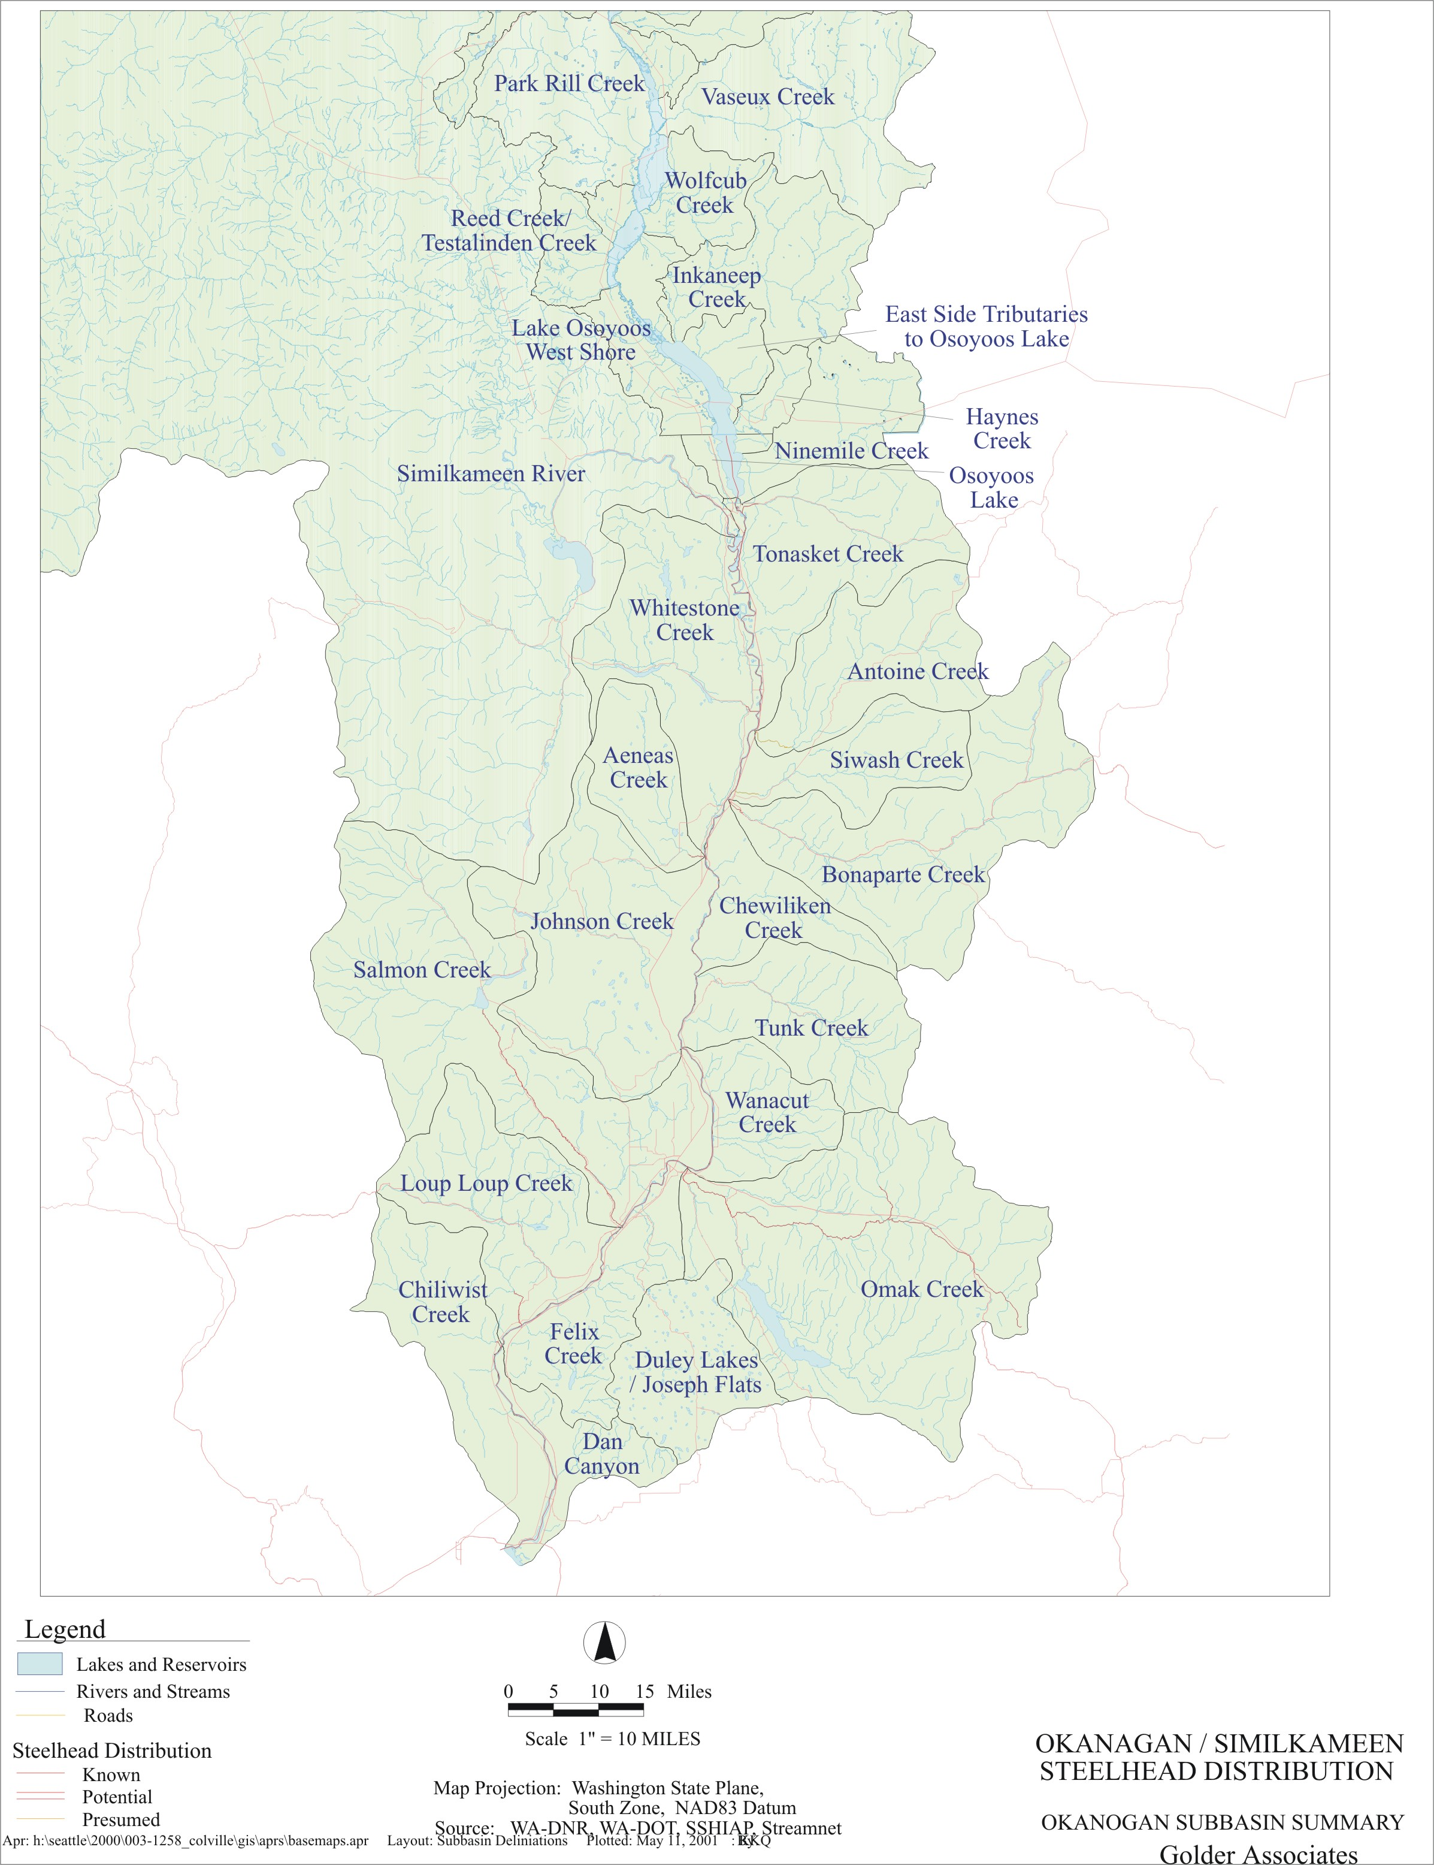
E-3. Steelhead Trout Distribution in the Okanogan/Similkameen River Basins.

